1. **Linux Overview**

Linux is a widely used open-source operating system, similar to Windows, Mac, and Android. It shares similarities with Unix, another operating system known for its commercial use. Unix and Linux have comparable components, including the kernel, shell, and programs. Many commands in Unix and Linux exhibit similar behaviour and syntax.

It was initially released by Linus Torvalds on September 17, 1991.

Linux distribution is an operating system that is made up of a collection of software based on Linux kernel or you can say distribution contains the Linux kernel and supporting libraries and software.

Ex: Debian, Ubuntu, RedHat etc.

1. **Architecture of Linux**

Linux architecture has the following components:

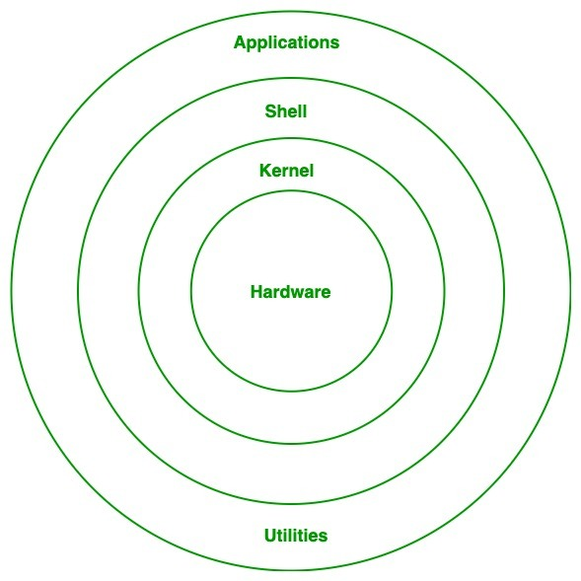

Kernel: Kernel is central component of an operating system that manages operations of computer and hardware. It basically manages operations of memory and CPU time. It is core component of an operating system.

Shell: A shell is basically an interface present between the kernel and the user. It takes commands from the user and executes the kernel’s functions.

Application and Utilities: Contains the Application and Utilities that runs by the commands from shell.

1. **Advantages / Features of Linux**

The main advantage of Linux is it is an open-source operating system. This means the source code is easily available for everyone and you are allowed to contribute, modify, and distribute the code to anyone without any permissions.

Linux is more secure than any other operating system.

It has large community support.

It provides high stability.

It maintains the privacy of the user.

It allows a large number of people to work at the same time and it handles them efficiently.

Multiuser and multi-tasking capabilities makes Linux one of the best Operating System.

1. **Windows vs Linux**

| **S.NO** | **Linux** | **Windows** |
| --- | --- | --- |
| 1. | [Linux](https://www.geeksforgeeks.org/introduction-to-linux-operating-system/) is a open source operating system. | While [windows](https://www.geeksforgeeks.org/advantages-and-disadvantages-of-windows-operating-system/) are the not the open source operating system. |
| 2. | Linux is free of cost. | While it is costly. |
| 3. | It’s file name case-sensitive. | While it’s file name is case-insensitive. |
| 4. | In linux, [monolithic kernel](https://www.geeksforgeeks.org/monolithic-kernel-and-key-differences-from-microkernel/) is used. | While in this, [micro kernel](https://www.geeksforgeeks.org/difference-between-microkernel-and-monolithic-kernel/) is used. |
| 6. | There is forward slash is used for Separating the directories. | While there is back slash is used for Separating the directories. |
| 7. | Linux provides more security than windows. | While it provides less security than linux. |
| 8. | Linux is widely used in hacking purpose based systems. | While windows does not provide much efficiency in hacking. |
| 9. | There are 3 types of user account –  (1) Regular , (2) Root , (3) Service account | There are 4 types of user account –  (1) Administrator , (2) Standard , (3) Child , (4) Guest |
| 10. | Root user is the super user and has all administrative privileges. | Administrator user has all administrative privileges of computers. |
| 11. | Linux file naming convention in case sensitive. Thus, sample and SAMPLE are 2 different files in Linux/Unix operating system. | In Windows, you cannot have 2 files with the same name in the same folder. |

1. **Linux File System**

Linux file system has a hierarchal file structure as it contains a root directory and its subdirectories. Root is the highest level of directory. Here is the list of sub-directories in the root directory.

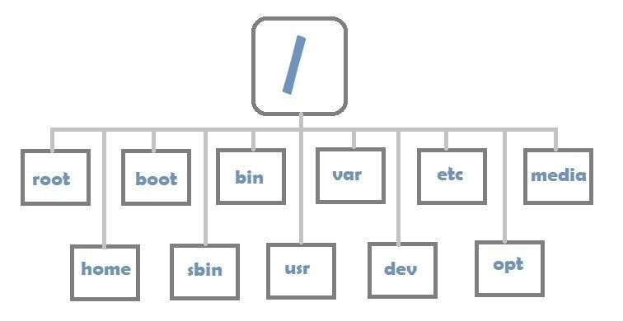

/root - Every single file and directory starts from the root directory. It is the home directory for the root user.

/bin – Essential user command binaries/executables

/sbin – contains command binaries that are used by system admin for config purpose

/boot – Static files of boot loader

/dev - contain device files, every device attached to the system presents as a file

/etc – contains config files required by all programs and startup and shutdown scripts

/proc – contains info about kernel and system process data.

/var – contains variable files include system log files, package database files, print queues, temp files.

/tmp - contains temporary files created by system and users. Removes when rebooted.

/usr - Contains binaries, libraries, documentation, and source-code for second level programs.

/usr/bin contains binary files for user programs.

/usr/sbin contains binary files for system administrators.

/usr/lib contains libraries for /usr/bin and /usr/sbin

/usr/local contains users programs that are installed from source.

/home - Home directories for all users to store their personal files.

/boot - Contains boot loader related files. Kernel initrd, vmlinux, grub files are located here

/lib - Contains library files that supports the binaries located under /bin and /sbin

/opt – contains add-on optional files of application software

/mnt - Temporary mount directory where sysadmins can mount filesystems.

/media - Temporary mount directory for removable devices.

/srv - Contains server specific services related data.

**Lab: Installing Linux Subsystem (Guest Linux OS) in Windows**

* Step1: Make sure to enable Windows Subsystem for Linux from Control Panel.

* Step2: Open Microsoft Store from Start Menu and search for ubuntu and get it.

1. **Linux Basic Commands**

1. ls -- list the contents of the directory

Ex: ls --color=auto

ls -l (Long listing of files)

ls -a (List includes hidden files)

ls -lh (list files in human readable format)

ls -r (list files in reverse order)

ls -ltr (list files and directories in reverse order)

ls -lS (list files by size)

Ex: $ls -ltr

2. hostname – Prints the hostname on terminal

Ex: $hostname

3. pwd -- print working directory

Ex: $pwd

4. man -- Displays command manuals.

5. $clear – clear the screen

Ex: $man mkdir

6. exit -- Ends the terminal session

Ex: $exit

7. sudo -- Superuser do

Ex: $sudo su -(logs in the user with root previlages)

8. ps -- running process information

Ex: ps

ps -e to list all the processes running, -ef with full format, -el long listing -aux full format, ps -u <username> all process initiated by that user.

ps -e |more lists page by page

9. kill -- kills the unresponsive process

Ex: kill 533494

Kill firefox

10. echo -- Print passed string on terminal

11. date –Prints date and time on Terminal

12. wget -- Download file from internet

ex: $ wget <https://dl.google.com/drive-file-stream/GoogleDriveSetup.exe>

13. tar -- used to compress files and folders

ex: $tar -xvf archive-name.tar

14. ping -- to test network connectivity

Ex: $ping

15. whoami -- displays the username currently in use

Ex: $whoami

16. whois – Display information from user directory.

Ex: $whois

17. ifconfig -- to assign an address to a network interface and to configure or display the current

network interface configuration information. If the command doesn’t work we need to install $apt-get install net-tools.

Ex: $ifconfig

18. mkdir -- Creates a new directory

Ex: mkdir -p movies/2004/ (Creates with subdirectories)

19. cd – change directory

Switches: cd / (changes to home directory)

cd (changes to home directory)

cd – (goes to previous directory)

cd.. (goes to parent directory)

20. rm -- remove files and directories

Ex: rm file_to_copy.txt

rm -r dir_to_remove/ (removes an empty directory)

rm -rf dir_with_content_to_remove/ (removes directory with content)

21. cp -- copy files and folders

Ex: cp file_to_copy.txt new_file.txt

cp -r 7. mv -- moves or renames a file

Ex: mv source_file destination_folder/ (moves a file)

mv /home/kinsta/BestMoviesOfAllTime ./ (moves a files with absolute path, ./ stands for the present directory)

mv old_file.txt new_named_file.txt (Renames a file)dir_to_copy/ new_copy_dir/ (Copy entire directory)

22. cat -- create, view, and concatenate files directly from the terminal

Ex: cat long_text_file.txt

cat>newfile.txt [ctrl+d to save]

23. touch -- updates the timestamp of the specified files, create new files with time stamp.

Ex: touch new_file_name

24. chmod- Change the file or directory permissions

r, w, x – read write execute permissions

u,g,o,a – User, group, other, all permissions

Ex: Symbolic Mode

chmod u+rwx <file_name> [Read, write, execute permissions to the owner]

chmod go-w [Remove write permission for the group and others}

chmod u+rw,go+r [Read, write for Owner, Read-only for the group and other]

Absolute Mode

Octal Mode

4 Read Permission

2 Write Permission

1 Execute Permission

Ex: chmod 674 <file_name>

25. chown – change file owner and group

To change owner of the file

chown owner_name file_name

Ex: chown suneelkb file1.txt

To change the group of the file

Ex: chown :groupname file1.txt

To change both owner and group of the file

Ex: chown suneelkb:groupname file1.txt

26. find -- command searches for files in a directory hierarchy based on a regex expression

Ex: find [flags] [path] -name [expression]

find ./ -name "long.txt" # ./long.txt (search a file long.txt in the current directory)

27. grep -- searches for lines that match a regular expression and print them

Ex: grep "linux" long.txt

grep -c "linux" long.txt ( Display the count)

28. diff command - diff stands for difference. This command is used to display the differences in the files by comparing the files line by line.

Ex: diff a.txt b.txt

29. sort -- used to sort lines of text files in ascending order. -r options to sort in descending.

30. tail -- prints the contents of a file, last 10 lines. Can be modified with -n

Ex: tail long.txt

tail -n 4 long.txt

31. useradd -- create a new user or update default new user information

ex: $useradd username

$useradd -m name -p password [-m creates user directory matches the user name]

32. passwd -- allows you to change the user passwords

Ex: sudo 29. userdel -- used to delete a user account and all related files passwd username

33. systemctl -- systemd management tool that is used to manage services, check running statuses, start and enable services and work with the configuration files

Ex: # systemctl start httpd.service

# systemctl enable httpd.service

# systemctl status httpd.service

# systemctl restart {servicename}(Restart service)

# systemctl reboot <poweroff> (Power off or reboot)

# systemctl get-default

# systemctl set-default graphical.target (boot gui)

# systemctl isolate multi-user.target (boot to cli)

# systemctl rescue (Switch to rescue mode for troubleshooting)

# systemctl list-units --type=service (to see status of all services)

# systemctl list-units --type=service --state=active

# systemctl list-units –failed

# systemctl mask {servicename} (mask, start, restart, stop, enable, disable, kill ect)

34. fdisk -- manipulate the disk partition table

35. shutdown -- Power Off the machine

Ex: $sudo shutdown now

$apt-get shutdown 20:40

36. shutdown -- Power Off the machine

Ex: $sudo shutdown now

$shutdown 20:40

37. sudo -- Superuser do

Ex: $sudo su -(logs in the user with root previlages)

1. **Nano and vi editor**

These commands are used to create files with content

Ex: $nano filename

$ vi filename

|  |  |
| --- | --- |
| **nano Commands** | **vi Commands** |
| CTRL + A Lets you jump to the beginning of the line.  CTRL + E Lets you to jump to the end of the line.  CTRL + Y Scrolls page down.  CTRL + V Scrolls page up.  CTRL + G A Help window will pop out and show you all the available commands.  CTRL + O To save the file. Nano will ask you to edit or verify the desired file name.  CTRL + W Search for a specified phrase in your text. Press ALT + W to search for the same phrase again.  CTRL + K It cuts the entire selected line to the cut buffer (similar to clipboard).  CTRL + U To paste the text from the cut buffer into the selected line.  CTRL + J Justifies the current paragraph.  CTRL + C Shows the current cursor position in the text (line/column/character).  CTRL + R Opens a file and inserts it at the current cursor position.  CTRL + X To exit Nano text editor. It prompts a save request if you made any changes to the file.  CTRL + \ Replaces string or a regular expression.  CTRL + T Invokes the spell checker, if available.  CTRL + _ Lets you go to the specified line and column number.  ALT + A To select text. You can combine this command with CTRL + K to cut a specific part of the text to the cut buffer. | s – delete a character (and move into insert mode)  dw – delete to end of the word  db – delete to beginning of the word  u – undo  Ctrl + r – redo  yy – copy (yank) entire line  dd – cut (delete) entire line  p – paste after the cursor  v – select text using character mode  V – select lines using line mode  aw – select a word  y – yank (copy) the marked text  d – delete (cut) the marked text  p – paste the text after the cursor  Saving and Exiting  :w – save the file  :wq – save and close the file  :q! – quit without saving changes  ^: set nu – sets the numbers  Moving the cursor by one character:  h – move the cursor left  l – move the cursor right  k – move the cursor up  j – move the cursor down  Moving the curser by word:  b – move to the start of a word  e – move to the end of a word  Moving curser by line:  0 (zero) – jump to the beginning of the line  $ – jump to the end of the line  :# – move to a specified line number  Moving by screen:  Ctrl + b – move back one full screen  Ctrl + f – move forward one full screen |

1. **Package Management**

Package management is a method of installing, updating, removing, and keeping track of software updates from specific repositories (repos) in the Linux system. To install packages we need to use apt module in Linux.

Ex: $apt-get command

$sudo apt-get install apache2 [To install package we need to add sudo, means to get super user privileges]

**Lab: Installing Linux through Oracle Virtual Box**

Step1: Download and install Virtual Box from the url

* <https://www.virtualbox.org/wiki/Downloads>

(Prerequisites: Install C++ Runtime 2019 from the url before installing virtual box)

(url: <https://learn.microsoft.com/en-us/cpp/windows/latest-supported-vc-redist?view=msvc-170#visual-studio-2015-2017-2019-and-2022>)

* Download Ubuntu Linux Server Image from the below url and copy to C:\Users\SuneelKB\VirtualBox VMs)

(url: <https://www.osboxes.org/ubuntu-server/>)

* Open Virtual Box Click on Menu item Machine and select new OS and fill the values Linux OS – Name and Type (Ubuntu Linux)

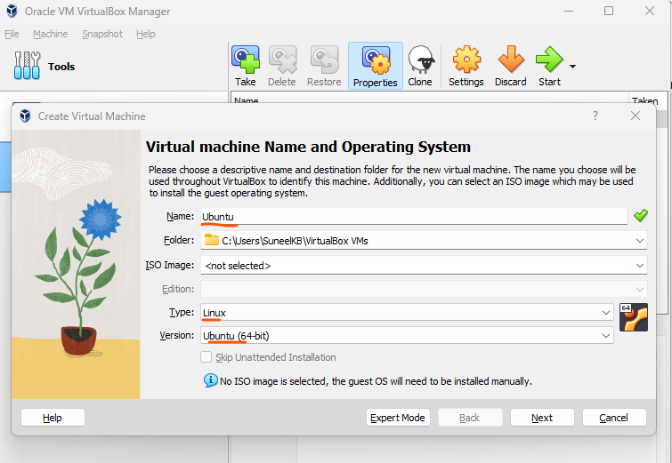

* Select RAM and Processor values to 1024mb and 1 Cpu.

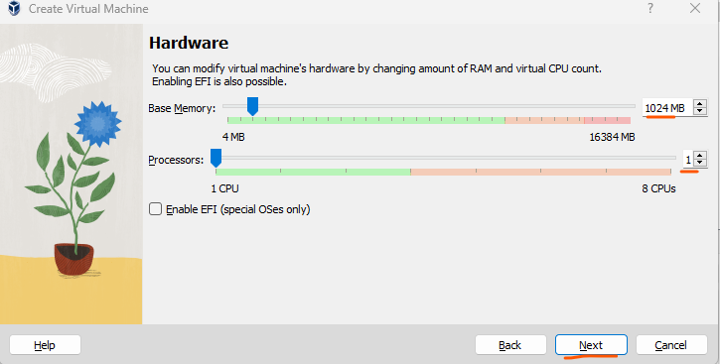

* Select use an existing hard disk image and add the Downloaded Linux image you copied to C:\Users\SuneelKB\VirtualBox VMs

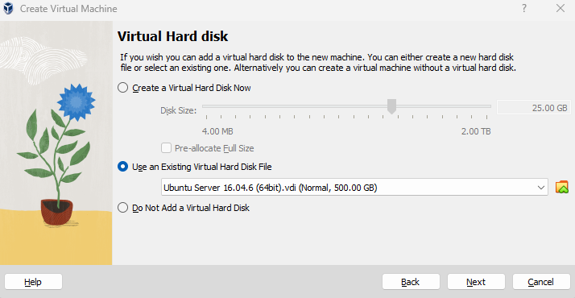

* Click Finish and start the Virtual Machine. The user name and password to log in to the Linux is
  + User: osboxes
  + Pwd: osboxes.org

---- End of the Course ----